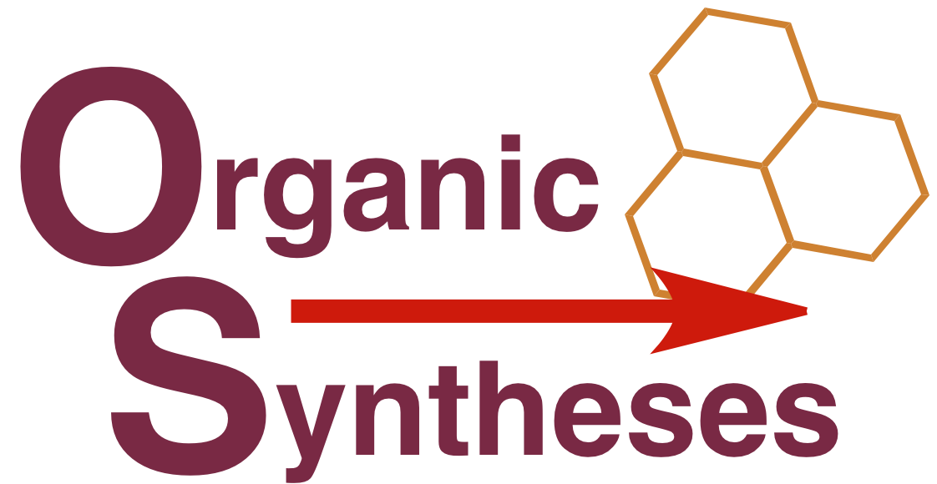 | Editor-in-Chief  Rick L. Danheiser  Department of Chemistry, Rm 18-298  Massachusetts Institute of Technology  Cambridge, MA 02139  Tel. 617 253-1842  Fax 617 252-1504  danheisr@mit.edu | Associate Editor  Charles K. Zercher  Department of Chemistry  University of New Hampshire  Durham, NH 03824  Tel. 603 862-2697  Fax 603 862-4278  org.syn@unh.edu

Organic Syntheses Summer Research Grant Program

Application Cover Sheet

Name

Mailing Address

Email Address

Phone Number

Website

Title of Proposed Research

Have you received an OS Summer Research Grant before? (Provide title and dates of funding)

Applications should be submitted as email attachments by December 1, 2021 to the office of the Editor in Chief at ospui@mit.edu. Complete applications must include

- This cover sheet
- Curriculum vitae including list of publications, indicating which papers represent research by undergraduate coworkers.
- List of most recent undergraduate coworkers (5-10 maximum) including their first position after graduation and current employment (if known).
- Indication whether your department has a graduate program in chemistry (e.g., Masters degree) and if so, a list of current and recent (past five years) graduate students under your direction.
- Description of proposed research (maximum 3 pages including figures, schemes, and references).
- Letter of support from the Chair of your department confirming the availability of space, equipment, and administrative support for the proposed research and confirming that undergraduate researchers will receive appropriate training in laboratory safety.

