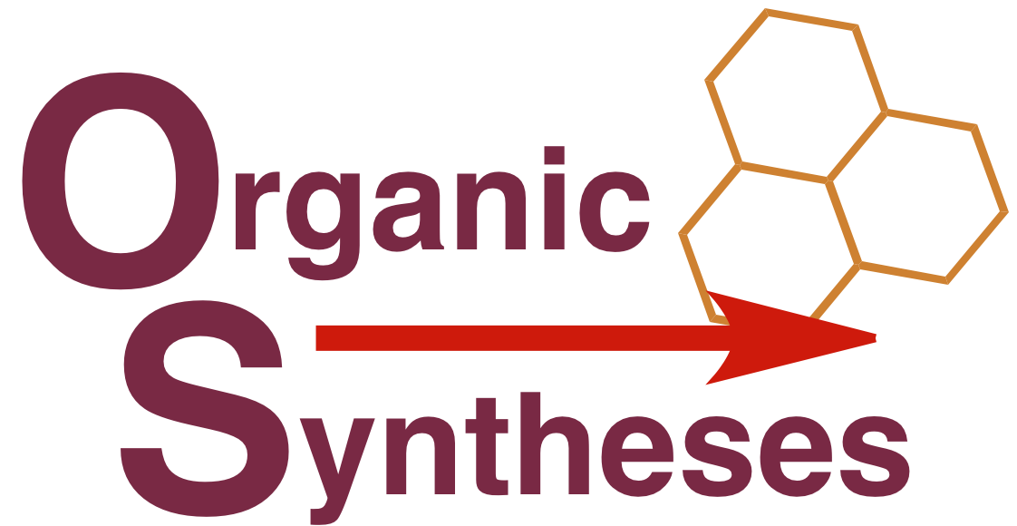 | Editor-in-Chief  Rick L. Danheiser  Department of Chemistry, Rm 18-298  Massachusetts Institute of Technology  Cambridge, MA 02139  Tel. 617 253-1842  Fax 617 252-1504  danheisr@mit.edu | Associate Editor  Richard E. Taylor  Department of Chemistry  University of Notre Dame  Notre Dame, IN 46556-5670  Tel. 574 631-5674  Fax 574 631-6652  rtaylor@nd.edu

Organic Syntheses Summer Research Grant Program

Application Cover Sheet

Name

Mailing Address

Email Address

Phone Number

Website

Title of Proposed Research

Have you previously received (a) OS Summer Research Grant(s)? (Provide title(s) and dates of funding)

Applications should be submitted as email attachments by November 1, 2025 to the office of the Editor in Chief at ospui@mit.edu. Complete applications must include the following (please check boxes to confirm inclusion)

- This cover sheet
- Curriculum vitae including list of publications. Please underline the names of undergraduate coworkers in your publication list.
- List of most recent undergraduate coworkers (10 maximum) including their first position after graduation and current employment (if known).
- Indication whether your department has a graduate program in chemistry (e.g., Masters degree or higher) and if so, a list of current and recent (past five years) graduate students under your direction.
- List of current research support. Include title of research, source of funding, total amount and amount per year, and period of support.
- Description of proposed research (maximum 3 pages including figures, schemes, and references).
- Letter of support from the Chair of your department confirming the availability of space, equipment, and administrative support for the proposed research and confirming that undergraduate researchers will receive appropriate training in laboratory safety.

