OS Techniques
Title of Article in 14 pt Bold Calibri (Word Style “OS Title”). See Instructions for Authors for guidelines in choosing title

Author Names in Palatino 11 pt (Word Style “OS Author”), Author Name, and Author Name with asterisk after name of author to whom correspondence should be addressed*

Author Address in Palatino 10 pt (Word Style “OS Author Address”)

Org Syn Checker(s) Name(s) in Palatino 11 pt (Word Style “OS Author”), and OS Editor Name last with superscript footnote 2 after name of OS editor*²

Checkers Address in Palatino 10 pt (Word Style “OS Author Address”)

Paste heading scheme in this box over this text. Use ACS ChemDraw settings for bond length, size of fonts for atom labels and captions, etc. The maximum width of the scheme in ChemDraw should be 15 cm and choose 75% for size after pasting into Word using “Format Picture” (Mac) or “Size and Position” (Windows).

Procedure (Note 1)

A. Name of compound (number). Type the experimental procedure here in Palatino 10 pt (Word Style “OS Main Text”) using “At Least 13 pt” for Line Spacing (setting is on the Paragraph panel accessed via the Format tab or via the Ruler). Note that this line spacing should also be used for the Notes, Discussion section, and References. Carefully follow the instructions provided on the Organic Syntheses website with regard to style and level of detail.
B. Name of compound (number). Type the experimental procedure for the second step (if any) here in Palatino 10 pt. Carefully follow the instructions provided on the Organic Syntheses website with regard to style and level of detail.
Figures embedded within the procedure should be centered justified and should be single jpg or png files using the format below. Figure legends should use bold Palatino 10 pt font follow with the format shown.
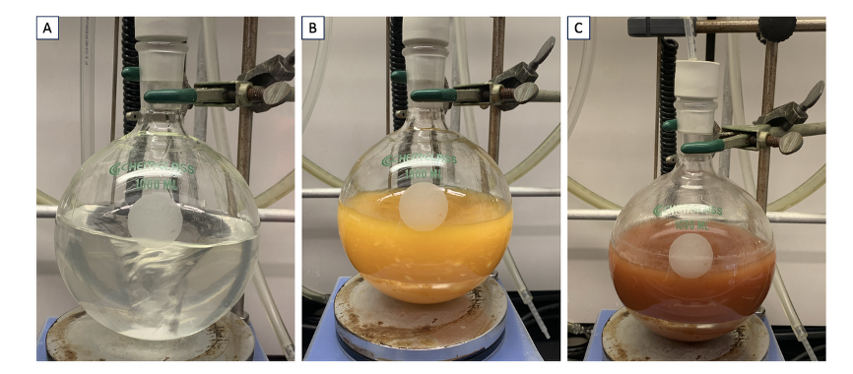
Figure X. A. Description; B. Description; C. Description

C. Add additional steps as necessary using the same format.
D. Add additional steps as necessary using the same format.
E. Add additional steps as necessary using the same format

Notes

- Prior to performing each reaction, a thorough hazard analysis and risk assessment should be carried out with regard to each chemical substance and experimental operation on the scale planned and in the context of the laboratory where the procedures will be carried out. Guidelines for carrying out risk assessments and for analyzing the hazards associated with chemicals can be found in references such as Chapter 4 of “Prudent Practices in the Laboratory" (The National Academies Press, Washington, D.C., 2011; the full text can be accessed free of charge at https://www.nap.edu/catalog/12654/prudent-practices-in-the-laboratory-handling-and-management-of-chemical. See also “Identifying and Evaluating Hazards in Research Laboratories” (American Chemical Society, 2015) which is available via the associated website “Hazard Assessment in Research Laboratories” at https://www.acs.org/about/governance/committees/chemical-safety.html. In the case of this procedure, the risk assessment should include (but not necessarily be limited to) an evaluation of the potential hazards associated with (enter list of chemicals here), as well as the proper procedures for (list any unusual experimental operations here). (Provide additional cautions with regard to exceptional hazards here).
- Information in the Notes should be typed in Palatino 10 pt (Word Style “OS Notes”) using “At Least 13 pt” for Line Spacing (setting is on the Paragraph panel accessed via the Format tab or via the Ruler). Follow the guidelines in the Instructions for Authors with regard to style and what information to provide in the Notes.
- Information in the Notes should be typed in Palatino 10 pt.
- Information in the Notes should be typed in Palatino 10 pt.
- Information in the Notes should be typed in Palatino 10 pt.
- Information in the Notes should be typed in Palatino 10 pt.
- Information in the Notes should be typed in Palatino 10 pt.
- Information in the Notes should be typed in Palatino 10 pt.
- Information in the Notes should be typed in Palatino 10 pt.
- Information in the Notes should be typed in Palatino 10 pt.
- Information in the Notes should be typed in Palatino 10 pt.
- Information in the Notes should be typed in Palatino 10 pt.
- Information in the Notes should be typed in Palatino 10 pt.

Working with Hazardous Chemicals

The procedures in Organic Syntheses are intended for use only by persons with proper training in experimental organic chemistry. All hazardous materials should be handled using the standard procedures for work with chemicals described in references such as "Prudent Practices in the Laboratory" (The National Academies Press, Washington, D.C., 2011; the full text can be accessed free of charge at http://www.nap.edu/catalog.php?record_id=12654). All chemical waste should be disposed of in accordance with local regulations. For general guidelines for the management of chemical waste, see Chapter 8 of Prudent Practices.
In some articles in Organic Syntheses, chemical-specific hazards are highlighted in red “Caution Notes” within a procedure. It is important to recognize that the absence of a caution note does not imply that no significant hazards are associated with the chemicals involved in that procedure. Prior to performing a reaction, a thorough risk assessment should be carried out that includes a review of the potential hazards associated with each chemical and experimental operation on the scale that is planned for the procedure. Guidelines for carrying out a risk assessment and for analyzing the hazards associated with chemicals can be found in Chapter 4 of Prudent Practices.
The procedures described in Organic Syntheses are provided as published and are conducted at one's own risk. Organic Syntheses, Inc., its Editors, and its Board of Directors do not warrant or guarantee the safety of individuals using these procedures and hereby disclaim any liability for any injuries or damages claimed to have resulted from or related in any way to the procedures herein.

Discussion

Type the discussion section here in Palatino 10 pt (Word Style “OS Main Text”). See the Instructions for Authors for guidelines on the content of the discussion section of articles.
If graphics such as Schemes, Tables, or Figures are included, the graphics should be prepared in a drawing program such as ChemDraw using the ACS ChemDraw settings for bond length, size of fonts for atom labels and captions, etc. The maximum width of the scheme or table in ChemDraw should be 15 cm and choose 75% for size after pasting into Word using “Format Picture” (Mac) or “Size and Position” (Windows). All graphics should be provided both embedded in the text and as a separate ChemDraw file.
Tables should be numbered and use 10 point Palatino Bold font for the titles, which is placed just above the table. Titles are recommended for schemes but are not required.

References

- Contact information for the authors should be given in Reference 1, including email address and ORCID of the corresponding author. Use Palatino 10 pt font (Word Style “OS References”) using “At Least 13 pt” for Line Spacing (setting is on the Paragraph panel accessed via the Format tab or via the Ruler). This footnote should include acknowledgment of financial support.
- Footnote 2 should read: Experimental verification (“checking”) was performed by (insert junior checker(s) name(s) xxxxx) under the supervision of Organic Syntheses Editor (insert editor’ name xxxxxxx) and with financial support from Organic Syntheses, Inc. Contact information for the editor should be given, including email address and ORCID of the editor. Use Palatino 10 pt font (Word Style “OS References”) using “At Least 13 pt” for Line Spacing (setting is on the Paragraph panel accessed via the Format tab or via the Ruler).
- References to the literature should be presented in ACS style, including title, the names of all authors, journal name, year, volume, and inclusive page numbers. DOIs must be included using the format DOI: 10.####/xxxxxxx.
- References to the literature should be presented in ACS style, including title, the names of all authors, journal name, year, volume, and inclusive page numbers. DOIs are recommended.
- References to the literature should be presented in ACS style, including title, the names of all authors, journal name, year, volume, and inclusive page numbers. DOIs are recommended.
- References to the literature should be presented in ACS style, including title, the names of all authors, journal name, year, volume, and inclusive page numbers. DOIs are recommended.
- References to the literature should be presented in ACS style, including title, the names of all authors, journal name, year, volume, and inclusive page numbers. DOIs are recommended.
- References to the literature should be presented in ACS style, including title, the names of all authors, journal name, year, volume, and inclusive page numbers. DOIs are recommended.

Appendix
Chemical Abstracts Nomenclature (Registry Number)

Name of compound as it appears in the text: CAS Name; (CAS Registry No.)
Name of compound as it appears in the text: CAS Name; (CAS Registry No.)
Name of compound as it appears in the text: CAS Name; (CAS Registry No.)
Name of compound as it appears in the text: CAS Name; (CAS Registry No.)
Name of compound as it appears in the text: CAS Name; (CAS Registry No.)
Name of compound as it appears in the text: CAS Name; (CAS Registry No.)
Name of compound as it appears in the text: CAS Name; (CAS Registry No.)

Insert photograph of each author here, and submit as a separate JPG file. A head-and-torso photo (4 cm x 5 cm) is preferred. | Biographical information can be typed here. Please limit the length of the biographical information to 100 words or fewer, if possible. Use Palatino 9-point font with single spacing (Word Style “OS Biography”). Submit photographs as separate JPG files.

Insert photograph of each author here, and submit as a separate JPG file. A head-and-torso photo (4 cm x 5 cm) is preferred. | Biographical information can be typed here. Please limit the length of the biographical information to 100 words or fewer, if possible. Use Palatino 9-point font with single spacing (Word Style “OS Biography”). Submit photographs as separate JPG files.

Insert photograph of each author here, and submit as a separate JPG file. A head-and-torso photo (4 cm x 5 cm) is preferred. | Biographical information can be typed here. Please limit the length of the biographical information to 100 words or fewer, if possible. Use Palatino 9-point font with single spacing (Word Style “OS Biography”). Submit photographs as separate JPG files.

